Ex. No. 2

**CONFIGURATION AND CREATION OF VIRTUAL MACHINE**

# AIM:

To configure a virtual machine using VMware and execute a simple program

# PROCEDURE:

1. Launch VMware
2. Create new virtual machine
3. Customize the set-up
4. Set username and password
5. Browse for .iso file of an operating system
6. Configure the hardware capacity
7. Finish and power on the VM
8. Install C or PYTHON OR JAVA Compiler and execute a simple program

# OUTPUT:

Download and install VMware Workstation Pro

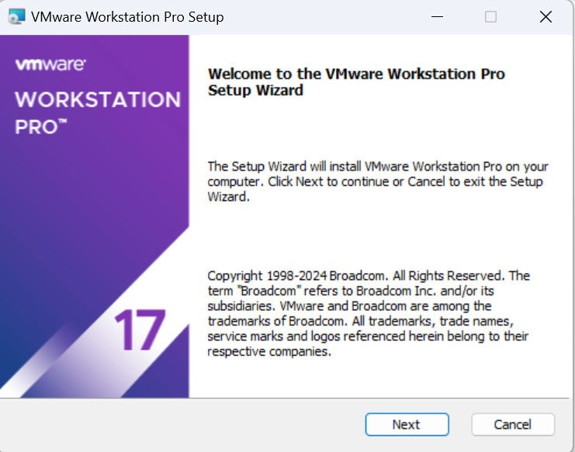

Open VMware Workstation Pro and create a new virtual machine

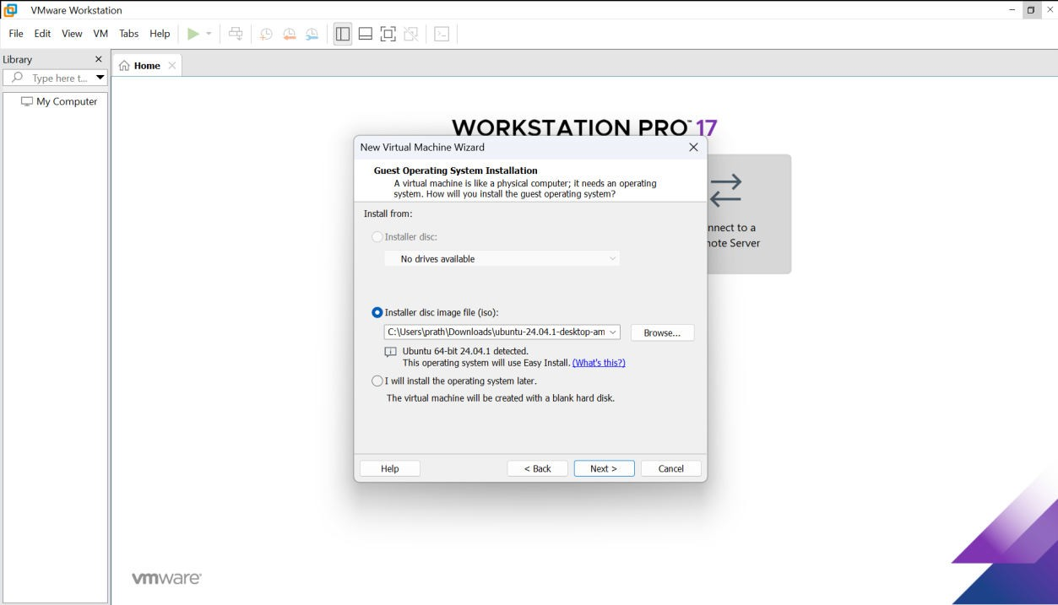

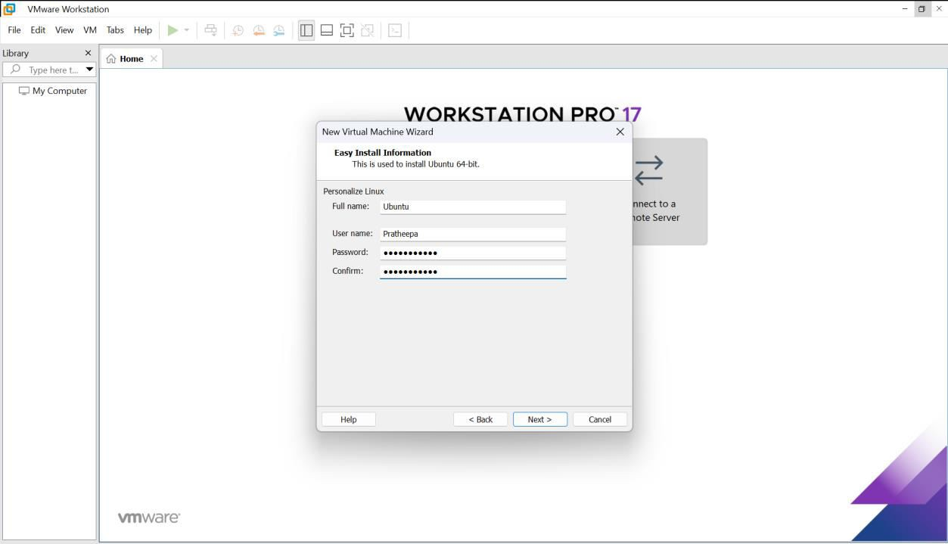

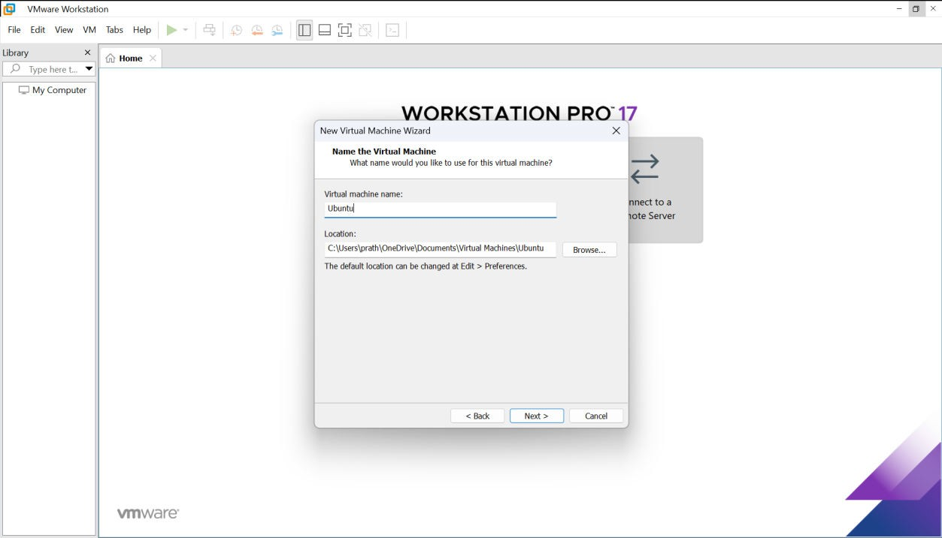

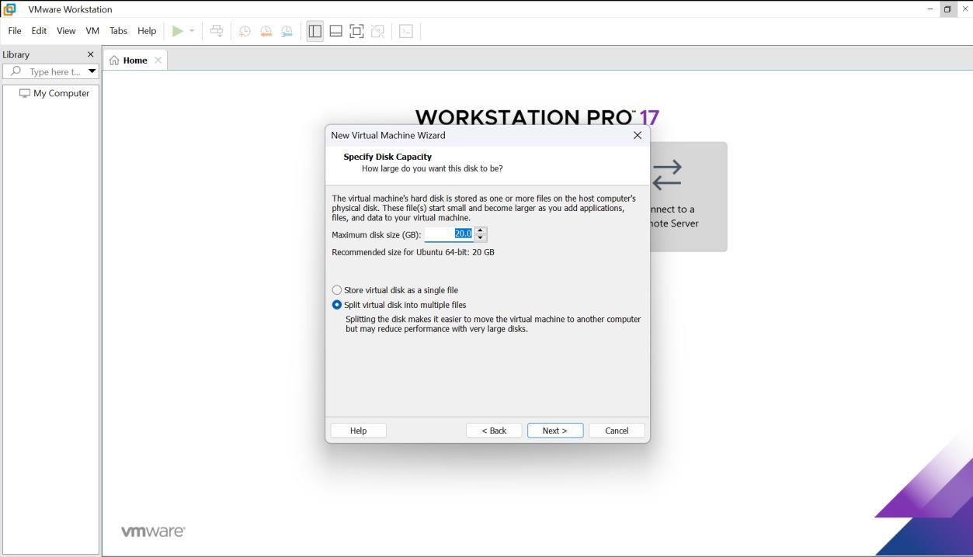

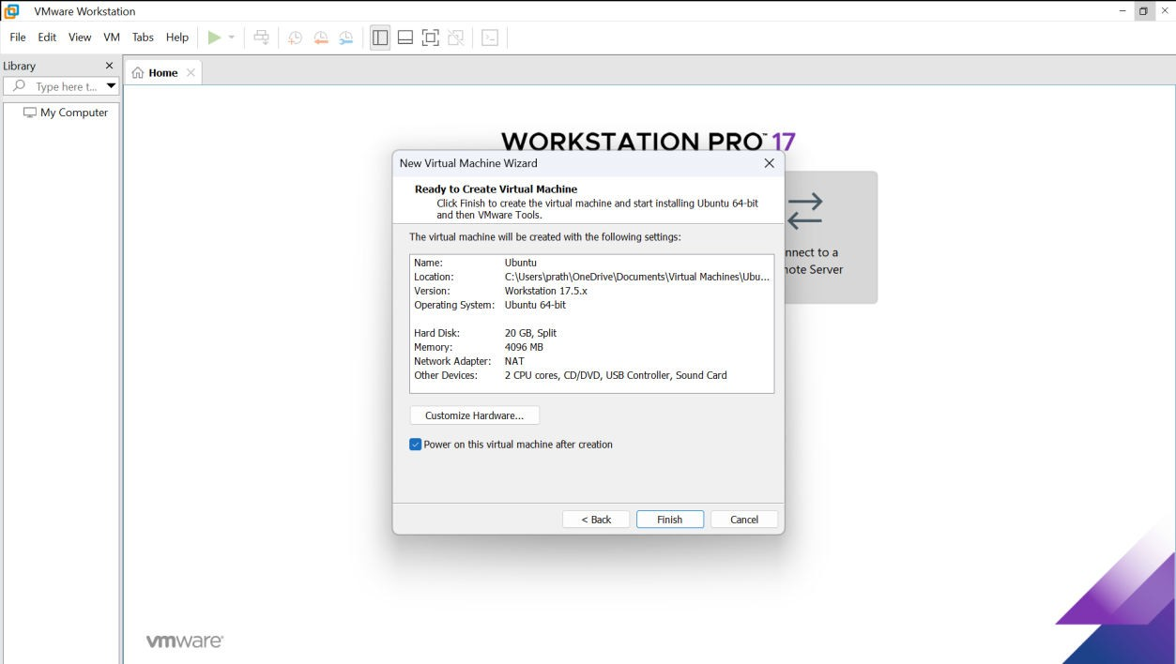

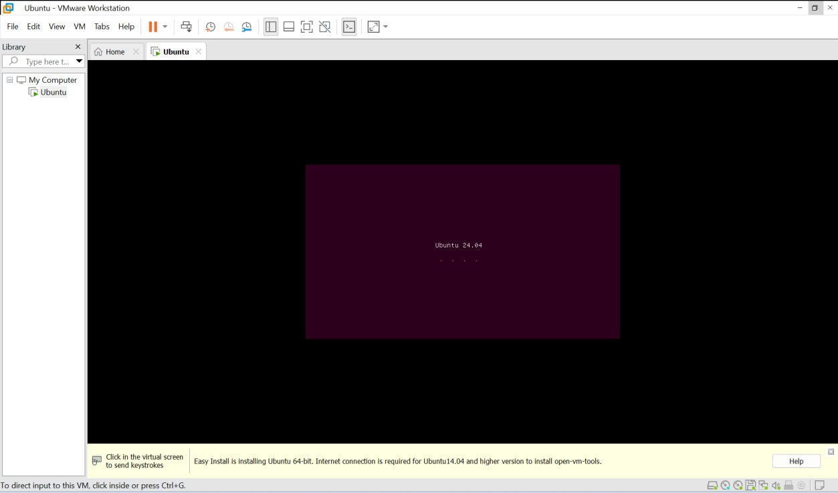

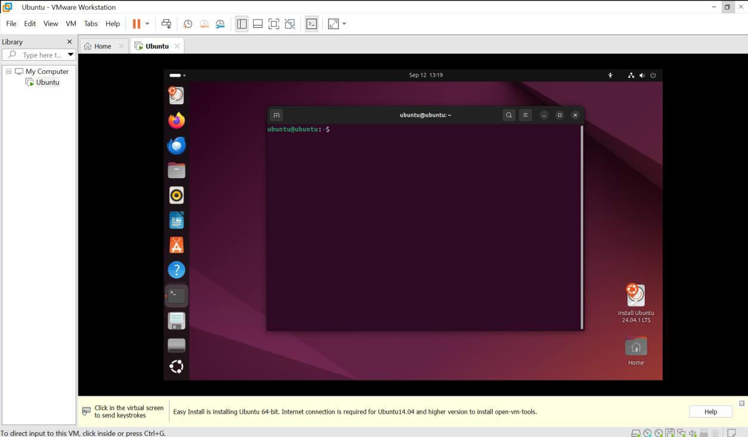

Create a Python program

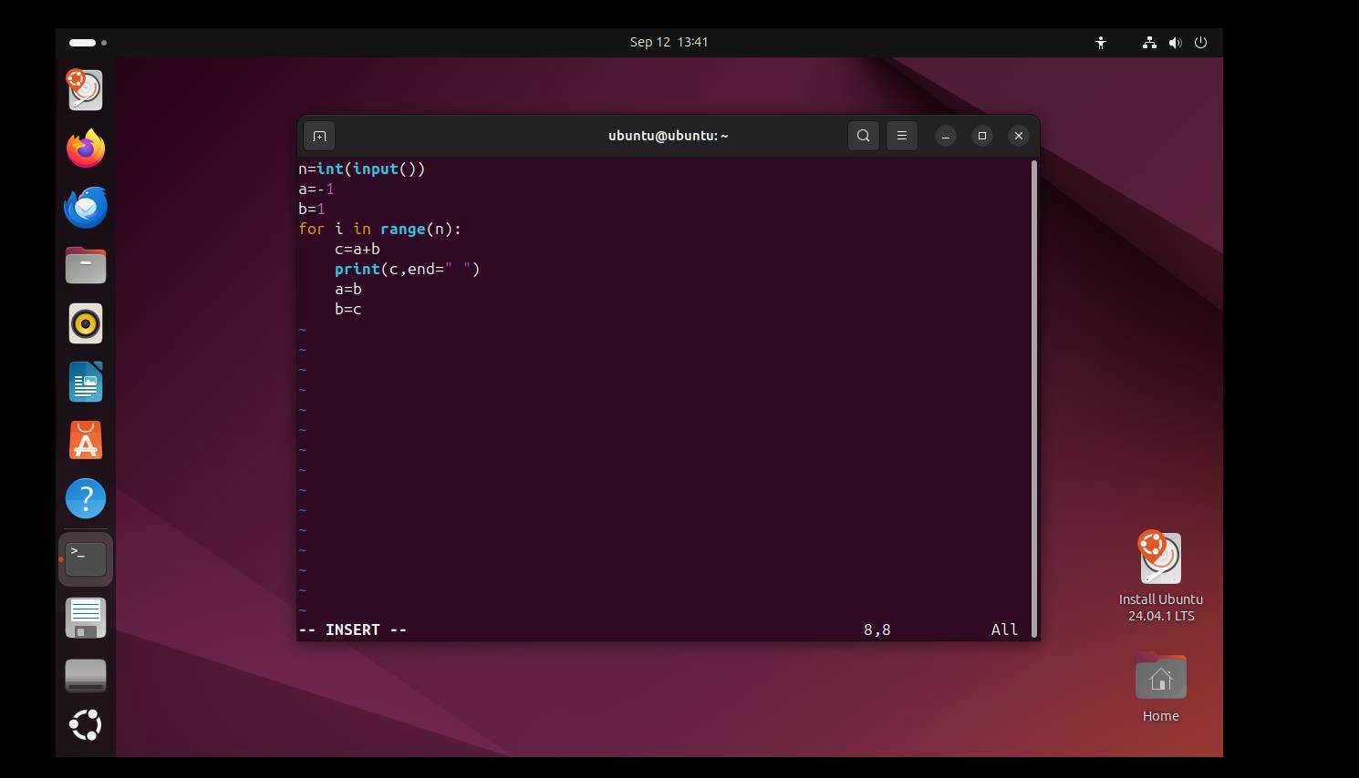

Run the program

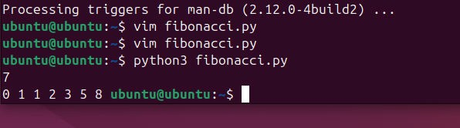

# RESULT:

A virtual machine is created using VMware Workstation Pro and a simple program is executed on the virtual machine.